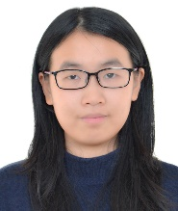
Dr Ying Huang received the B. Eng. Degree in electrical engineering from the Wuhan University, Wuhan, China, in 2013, and the Ph. D. degree in electrical and electronic engineering from the University of the Hong Kong, Hong Kong, in 2018. From March 2014 to August 2014, she was a research assistant in Department of Electrical and Electronic Engineering from the University of Hong Kong, Hong Kong. She is currently a post-doctoral fellow in Department of Electrical and Electronic Engineering, the University of Hong Kong. Her current research interests include switched-capacitor converter, resonant converter, wireless power transfer system, and renewable energy applications. She is the recipient of the best paper award at the 8th Annual IEEE Energy Conversion Congress & Expo (IEEE ECCE 2016).

